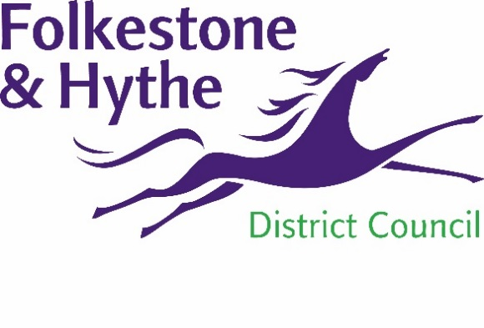
NEWS RELEASE

23 February 2021

PRINCES PARADE SCHEME IS A STEP CLOSER TO REALITY AS CONSTRUCTION CONTRACTOR APPOINTED

Folkestone & Hythe District Council has appointed BAM Construction to deliver a new leisure centre, promenade and infrastructure works to facilitate this and the residential developments at Princes Parade in Hythe.
Construction will begin on site during the first quarter of 2022, however, preparatory work will begin on site as early as next month. On site testing commences in March to inform the final design of the substructure works for the development. This will be undertaken with expert ecological advice. Design for the realigned road and services has also commenced.
BAM have committed to hosting more than 340 hours of apprentice and trainee training time creating opportunities for local people. The same core team from BAM who worked on the highly acclaimed Dover Leisure Centre will be working on the Princes Parade development.
Cllr David Monk, Leader of Folkestone & Hythe District Council, said: “We’ve long held ambitions to replace our popular but old and tired swimming pool in Hythe. Improving physical and mental wellbeing is one of our key priorities for the next three years as part of our commitment to positive community leadership in our new Corporate Plan.
“Back in 2012 Princes Parade – a former municipal waste tip – was identified as the preferred location for this development. There have been years of careful deliberation, public consultation and painstaking preparation involved in this project. We think the residents of Hythe and the wider district deserve a new swimming pool and leisure facilities fit for the 21st century.
“I’m delighted that this project is finally becoming a reality and I look forward to watching this community asset take shape.”
BAM’s Construction Manager Daniel Brenchley, who has built across Kent in his career, said: “We have exactly the right experience having delivered leisure facilities in coastal positions around the country and with our civil engineering heritage especially in a marine environment.
“We know that working considerately is extremely important and we’re committed to using our time here to help people with local career development through jobs, orders and training.”
“We will be working with our supply chain and local agencies to create new construction jobs here which will be advertised through local employment vehicles such as Job Centre Plus. We’re actively looking at training plans with our supply chain partners for developing skills and training opportunities too.”
BAM, which has completed over 100 contracts in Kent and has a continuous presence in the county - is initially operating on a PCSA – a pre-construction services agreement – while the full design of the scheme is finalised. The scheme is being procured through the Southern Construction Framework (SCF).
For more information about the Princes Parade scheme please visit folkestone-hythe.gov.uk/princesparade

ENDS

Notes to Editors:
About BAM – BAM Construction in the South East is part of BAM Construct UK, in turn, part of the international Royal BAM Group. For over 150 years the company has been at the leading edge of technical and social change in the built environment. It is a market leader in digital construction techniques, and is a pioneer in 3D concrete printing. The company has been behind some of the most significant and modern buildings around the world, such as the new Museum of the Future in Dubai, as well as some of our oldest heritage. It employs some 19,000 people and its combined UK operations have turnover in the region of £1.7 billion pounds. In Kent it created Bluewater Events Centre, and its education sector expertise has seen it chosen to deliver many schools including those for pupils with special needs.
For more information, please email communications@folkestone-hythe.gov.uk and for BAM, contact mslattery@bam.co.uk

To keep up to date with the latest council news:

Follow us on Facebook: @FolkestoneandHytheDC
Follow us on Twitter: @fstonehythedc
Follow us on Instagram: @folkestonehythedc
Follow us on LinkedIn: Folkestone & Hythe District Council

